Retry pattern

In microservices network we can implement retry attempts when any of the microservice is failed for processing user request this we can collaborate with circuit break pattern that is before making the circuit break pattern to open. Retry pattern will perform the number of retry attempts on microservices. Also we need to keep in mind that we need to perform retry attempts only on idempotent operations that means it produces the same result for eg: get operations. We should not have to perform retry on update or save operations as it causes duplicate records or some other issue.

We can also set backoff for retry attempts that is we can add retry time incremental for every requests. For eg: if first attempt takes 5 seconds then second attempts take 10 seconds and third takes 15 seconds. And also we need to add max backoff else it will keep on increasing the wait time

Implement retry pattern in spring cloud gateway add the filter retry and also setMethod define for which http method we need to perform retries.

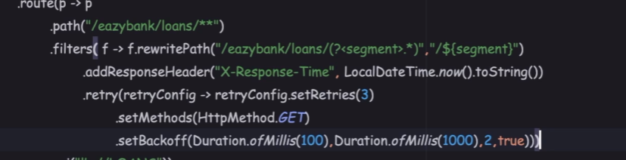

To check this working we can add throw new RunTimeException() in get method as below

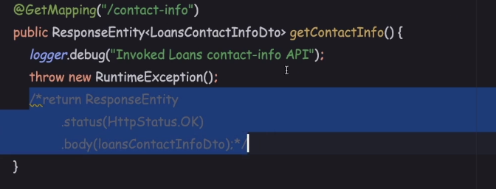

Now lets try calling this method from postman as you can see below the request gets failed due to exception and in console you can see multiple times the api gateway is trying to call the get method again.

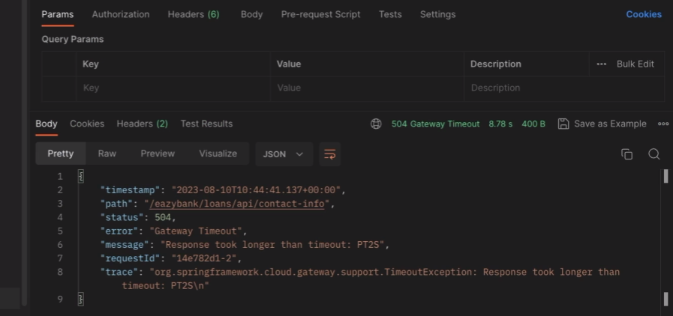

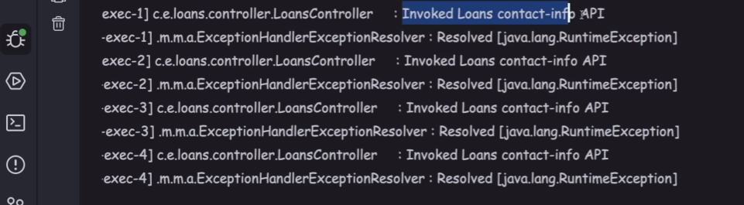

We can also add retry pattern to the individual http methods inside the different microservices instead of defining it in api gateway

You can do it by adding @Retry annotation to the individual methods as below then add the attributes name , fallBackMethod. Here there are some rules to create fallBackMethod ie it should have the same method signature as that on which it is being called.it contains only 1 param Throwable. Then add the retry properties in application.properies

In accounts controller

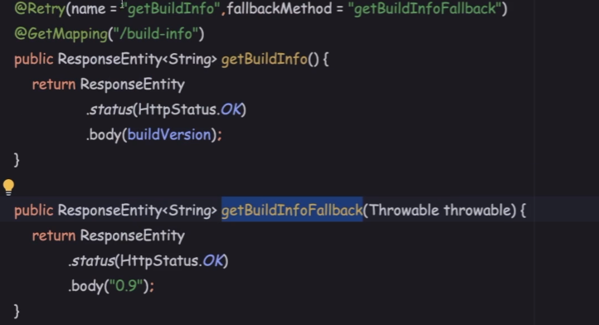

Below are the properties and this will apply to all the @Retry annotations

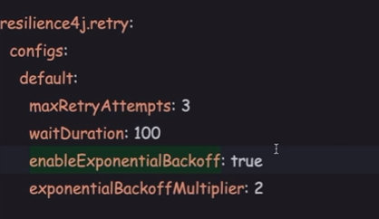

If we want to make properties to specific method then name specified in @Retry should be added in properties file here its **getBuildInfo**

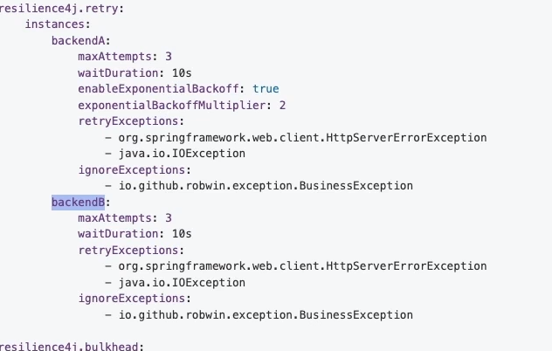

Custom timeout period for circuit breaker, the default timeout period is 1 second we need to change this to more than the number of retry attempts time else before retry only our circuit breaker will make open and hence no use of retry. So to change the default timeout we need to set in application file of gateway server.

As you can see below wait duration for each retry attempt is 500 miliseconds and attempts are 3 with exponential wait will be 2(500>1000>2000 exponential ) seconds but our circuit breaker timeout is 1 second hence circuit breaker fallback method will be called first.

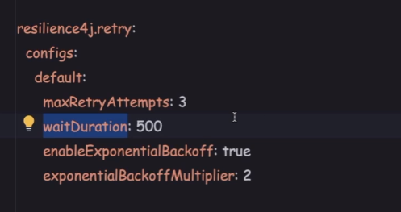

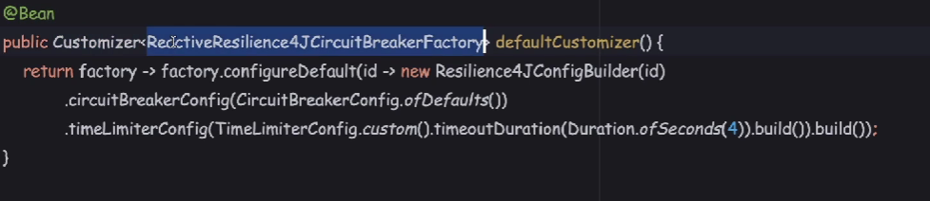

We can also ignore exceptions that our http get method will throw as shown below we can define multiple exceptions as list

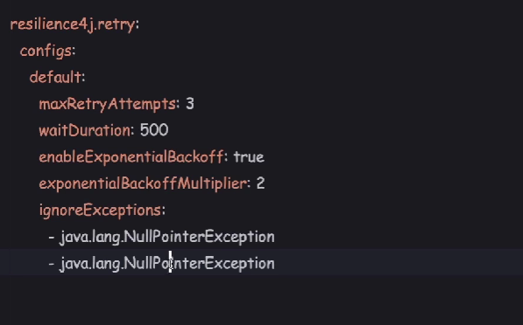

Also we can perform retry specific exceptions and all other exceptions related to ingoreExceptions will be automatically be ignored hence modified properties would be

